Gold Standard PBL Planning Guide

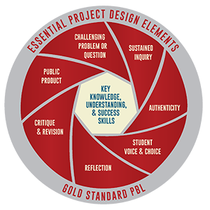

Factors of Great Projects | Description | Evidence
Key Knowledge, Understanding, and Success Skills | Project contains rigorous content, critical thinking/problem solving, collaboration, and self-management.
Challenging Problem or Question | The project is a problem to investigate and solve, or a question to explore and answer. It could be concrete (the school needs to do a better job of recycling waste) or abstract (deciding if and when war is justified).
Sustained Inquiry | Students must inquire is to seek information or to investigate – it’s a more active, in-depth process than just “looking something up” in a book or online.
Authenticity | The concept has to do with how “real-world” the learning or the task is. A project can have personal authenticity when it speaks to students’ own concerns, interests, cultures, identities, and issues in their lives.
Student Voice & Choice | Having a say in a project creates a sense of ownership in students; they care more about the project and work harder.
Reflection | Throughout a project, students – and the teacher – should reflect on what they’re learning, how they’re learning, and why they’re learning.
Critique and Feedback | Students should be taught how to give and receive constructive peer feedback that will improve project processes and products, guided by rubrics, models, and formal feedback/critique protocols.
Public Product | A “product” can be a tangible thing, or it can be a presentation of a solution to a problem or answer to a driving question.

